

Configuration Manual

MSc Research Project Cloud Computing

Sai Dhawanjewar

Student ID: 22130063

School of Computing

National College of Ireland

Supervisor: Dr. Giovani Estrada

**National College of Ireland MSc Project Submission Sheet School of Computing**

|  |  |  |  |
| --- | --- | --- | --- |
| **Student Name:** | Sai Dhawanjewar |  |  |
| **Student ID:** | 22130063 | | |
| **Programme:** | MSc Cloud Computing | **Year:** | 2023 |
| **Module:** | MSc Research Project | | |
| **Lecturer:** | Dr. Giovani Estrada | | |
| **Submission Due Date:** | 06/01/2024 | | |
| **Project Title:** | Improving Fault Tolerance and Consistency in Microservices with a temporary DB | |  |
| **Word Count:** | 2109 **Page Count:** 18 | | |

I hereby certify that the information contained in this (my submission) is information pertaining to research I conducted for this project. All information other than my own contribution will be fully referenced and listed in the relevant bibliography section at the rear of the project.

ALL internet material must be referenced in the bibliography section. Students are required to use the Referencing Standard specified in the report template. To use other author's written or electronic work is illegal (plagiarism) and may result in disciplinary action.

|  |  |
| --- | --- |
| **Signature:** | Sai Dhawanjewar |
| **Date:** | 06/01/2024 |

**PLEASE READ THE FOLLOWING INSTRUCTIONS AND CHECKLIST**

|  |  |
| --- | --- |
| Attach a completed copy of this sheet to each project (including multiple copies) | □ |
| **Attach a Moodle submission receipt of the online project submission,** to each project (including multiple copies). | □ |
| **You must ensure that you retain a HARD COPY of the project**, both for your own reference and in case a project is lost or mislaid. It is not  sufficient to keep a copy on computer. | □ |

Assignments that are submitted to the Programme Coordinator Office must be placed into the assignment box located outside the office.

|  |  |
| --- | --- |
| **Office Use Only** | |
| Signature: |  |
| Date: |  |
| Penalty Applied (if applicable): |  |

Configuration Manual

Sai Dhawanjewar Student ID: 22130063

# Introduction

This manual describes how to set up a test environment and run fault-tolerant microservices in Docker. It provides instructions for academics and student on how to install the required software and run the research project.

# Required Software Tools

The following software tools are required for the project's execution:

|  |  |  |
| --- | --- | --- |
| **Tool** | **Version** | **Use** |
| Docker | 24.0.6 | Containerization platform for deploying and managing applications |
| VS Code | 1.85.1 | Integrated development environment for developing microservices and React applications |
| Browser | Chrome: 120.0  Firefox: 120.0 | Web browsers for testing and debugging the UI application |
| Python | 3.11.1 | The programming language used for the development of microservices-based applications |
| Django | 3.2.18 | A high-level Python web framework utilized for building microservices-based applications with efficiency and rapid development |
| React JS | 18.2.0 | JavaScript library for efficient development of dynamic, component-based web interfaces |
| MySQL | Mysqlclient: 2.0.1  django-mysql: 3.9 | A relational database management system used for storing and managing data in microservices-based applications |
| Git bash | 2.43.0 | A version-controlled collaborative space facilitating seamless cooperation, code transparency, and parallel development for efficient project management. |

# Note : Please follow the specific instructions for your operating system to install the prerequisites, as these requirements were installed and run on Windows 11

# Hardware Requirements

* + Operating system: Windows/ Mac/ Linux (We can use any OS).
  + RAM: Minimum 8GB / 16GB or more than needed.
  + Processor: Any Processor from the Intel Core is suitable.

# Prerequisite installation

The steps for the installation of software and tools are shown below.

1. **Docker**

**Step1:** DownloadDocker from official website: <https://docs.docker.com/desktop/install/windows-install/>

**Step 2:** Click on button “Docker Desktop for windows**”.** It will start downloading docker.

**Step 3:** Run the installer you downloaded.

**Step 4:** Follow the installation wizard's instructions.

**Step 5:** During installation, Docker Desktop may ask to enable Hyper-V and Windows features. Allow these changes if prompted.

**Step 6:** Launch Docker Desktop: Once the installation is complete, you can launch Docker Desktop from the Start menu.

**Step 7:** You may need to sign in using your Docker Hub account. If you don't have one, you can create it during the installation process.

**Step 8:** Docker Desktop will configure itself and start the necessary services. This might take a few minutes.

**Step 9:** Check Docker Version: Open a command prompt or PowerShell window. Type docker version and press Enter. This command should display information about your Docker installation.

1. **VS Code**

**Step 1:** Download Visual Studio Code: <https://code.visualstudio.com/download>, Click on the "Download for Windows" button.

**Step 2:** Once the download is complete, run the installer (the .exe file you downloaded).

**Step 3:** Follow the instructions in the installation wizard. It may ask you to accept the license agreement and choose installation options.

**Step 4:** Click the "Install" button to start the installation process.

**Step 5:** Once the installation is complete, you can launch Visual Studio Code from the Start menu or desktop shortcut.

1. **Browser**

**Step 1:** Visit the official Google Chrome website: https://www.google.com/chrome/

**Step 2:** Click on the "Download Chrome" button.

**Step 3:** The website will automatically detect your operating system and provide the appropriate download link**.**

**Step 4:** Click on the download link to start the download.

**Step 5:** Once the download is complete, run the installer.

**Step 6:** Follow the on-screen instructions in the installation wizard.

**Step 7:** Chrome will be installed on your system, and you can launch it from the Start menu or desktop shortcut.

Note : Follow same procedure to install firefox: https://mozilla-firefox.en.softonic.com/download

1. **Python**

**Step 1:** Download Python: <https://www.python.org/downloads/>, Click on the "Downloads" tab.

You'll see the latest version of Python. choose between Python 3.x and Python 2.x. It is strongly recommended to use Python 3 as Python 2 has reached its end-of-life.

**Step 2:** Click on the download link for the installer corresponding to your Windows architecture (32-bit or 64-bit). Most modern Windows installations are 64-bit.

**Step 3:** Once the installer is downloaded, run it by double-clicking on the downloaded file

**Step 4:** Installation Wizard:

* Check the box that says "Add Python x.x to PATH" during the installation. This makes it easier to run Python from the command line.
* You can choose the "Customize installation" option to customize the installation location, but the default settings are usually fine for most users.
* Click on "Install Now" to start the installation.

**Step5:** Verify Python Installation:

* Open a command prompt or PowerShell window.
* Type python --version or python -V and press Enter. This should display the installed Python version.

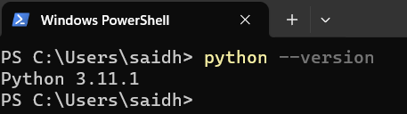

If you see the Python version, it means the installation was successful.

1. **Django**

**Step 1:** Open ‘cmd’ or ‘powershell’ or ‘Win+R’ and type command – “pip install django” and press enter. This command will use the Python package manager (pip) to download and install the latest version of Django.

**Step 2:** After the installation is complete, you can verify that Django is installed by checking its version. In the command prompt or PowerShell, type: python -m django –version.

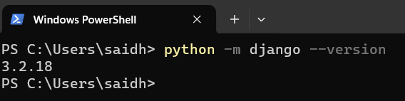

**Step 3:** Navigate to the Project Directory with command – “cd projectname”

**Step 4:** Run the Development Server: To test the installation, run the following command to start the Django development server – “python manage.py runserver”. This will start the development server, and you should be able to access your Django application by visiting http://127.0.0.1:8000/ in your web browser.

1. **React JS**

**Step 1:** Install Node.js and npm: <https://nodejs.org/en/download/current>

* Download the LTS (Long Term Support) version, which is recommended for most users.
* Run the installer and follow the installation instructions.

**Step 2:** Verify Installation: Open a command prompt or terminal window.Type the following commands to check if Node.js and npm are installed: node -v, npm -v

These commands should display the installed Node.js and npm versions.

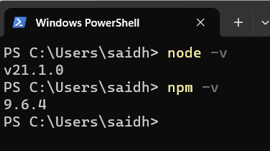

**Step 3:** Create a React App: Install it globally using npm: “npm install -g create-react-app”

**Step 4:** Create a New React App:

* In the command prompt or terminal, navigate to the directory where you want to create your React app.
* Run the following command to create a new React app: “npx create-react-app my-react-app”

**Step 5:** Navigate to the App Directory: Change your current directory to the newly created app directory: “cd my-react-app”

**Step 6:** Run the Development Server: Start the development server with the following command: “npm start”

This will launch your React app, and you can view it by visiting http://localhost:3000 in your web browser.



# Running proposed solution

# Step 1: Start Docker engine.

# Click on ‘Docker Desktop’ application → It will open Docker application. → Then sign in with your credentials.

# Step 2: Open Visual studio code

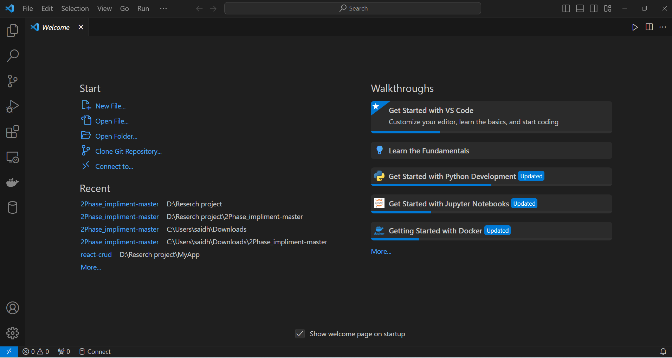

**Step 3: Open project “2Phase_impliment-master”.**

Click on ‘Files’ → Click on ‘Open folder’ → Select project folder ‘2Phase_impliment-master’

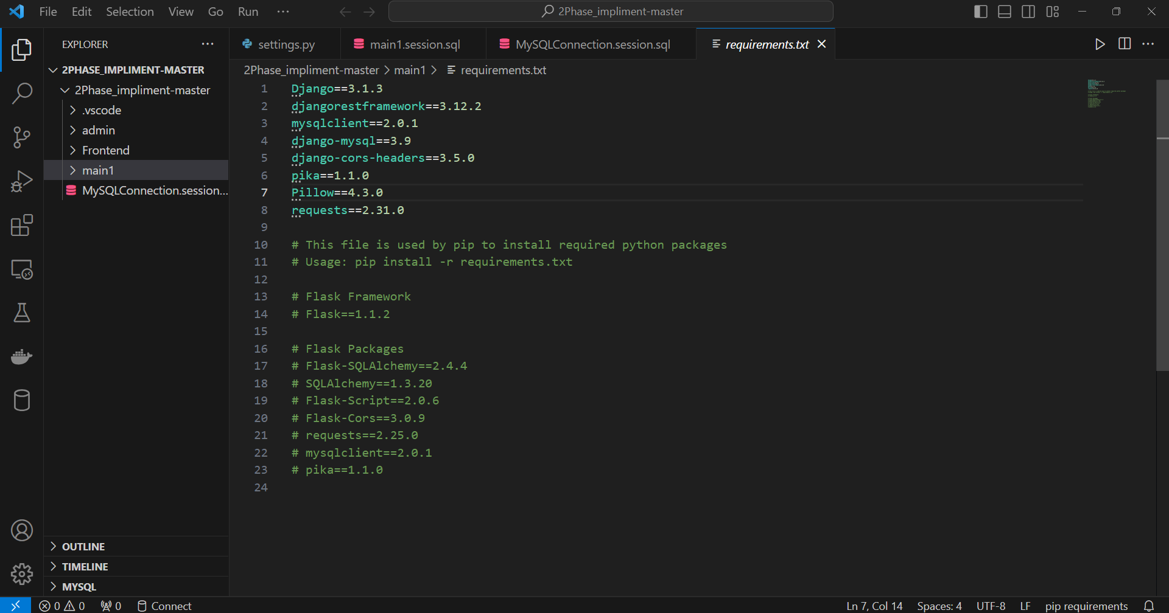

**Step 4: Configure the IP address according to the internet connectivity for both the 'admin' and 'main1' services, as they will be required for API access in the project.**

* First check available IP’s. Go to command prompt → type command ‘ipconfig’

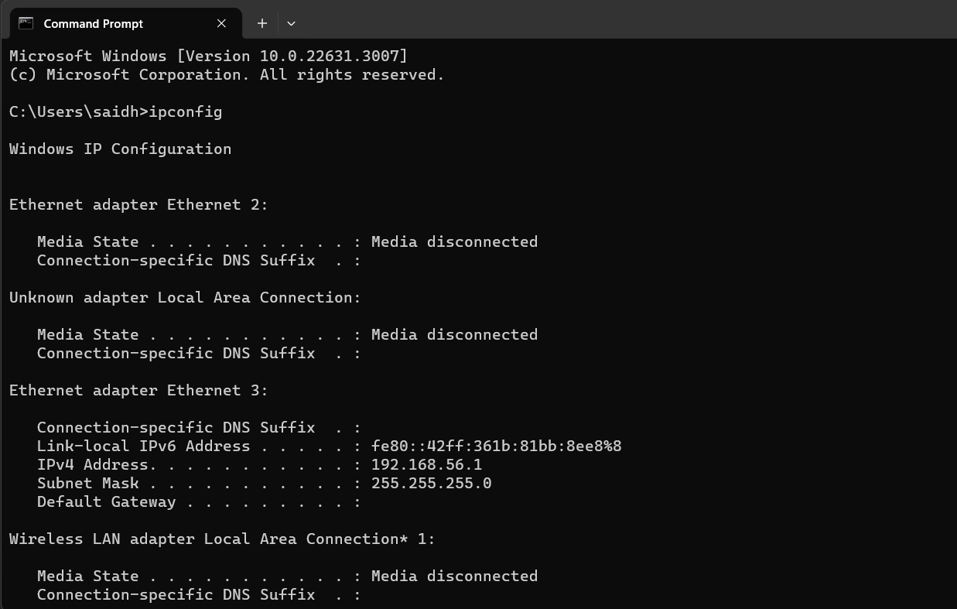

It will show you all available IP’s.

* Here using IPv4 192.168.0.208 which is available for LAN adapter wifi. You can change it as per your connectivity.
* Set this IP for all services.
* Go to VS code. → select microservice ‘admin’ → select app ‘admin’→ select file ‘settings.py’
* Copy IP added in Allowed host other than local host 
* Replace it with new IP selected as per your LAN availability.
* To replace IP same time at all locations click on  . Then enter old IP in first box and new IP in second box. And click on replace all button 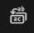 .

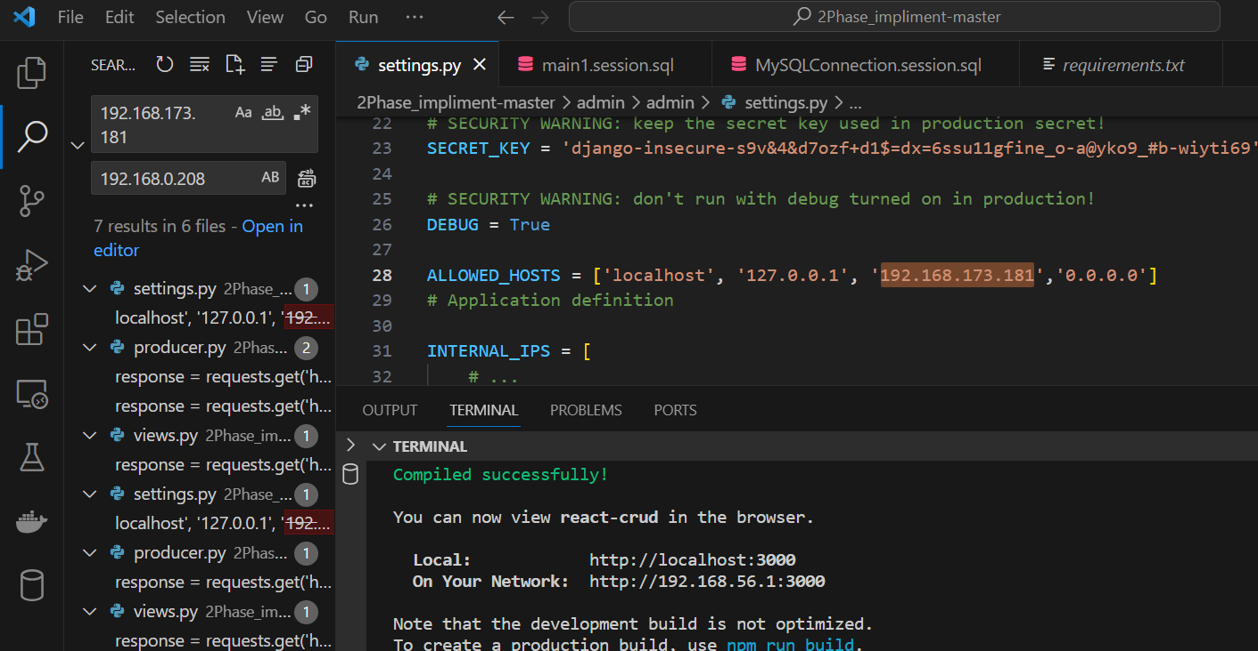

**Step 4: Deploy microservice “admin” on docker.**

* Right click on microservice ‘admin.’ → select option ‘Open in Integrated Terminal.’

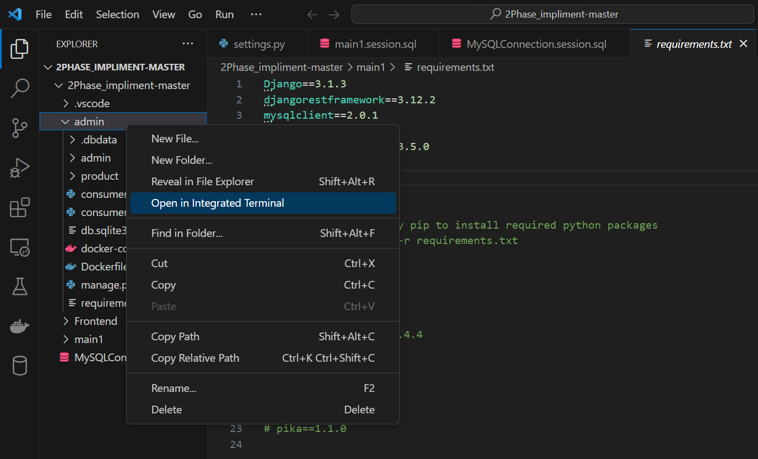

* It will open the terminal window.

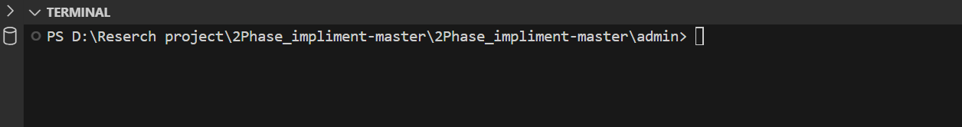

* Now enter the command ‘**docker-compose up –build**’ to deploy microservice ‘admin’ on docker.

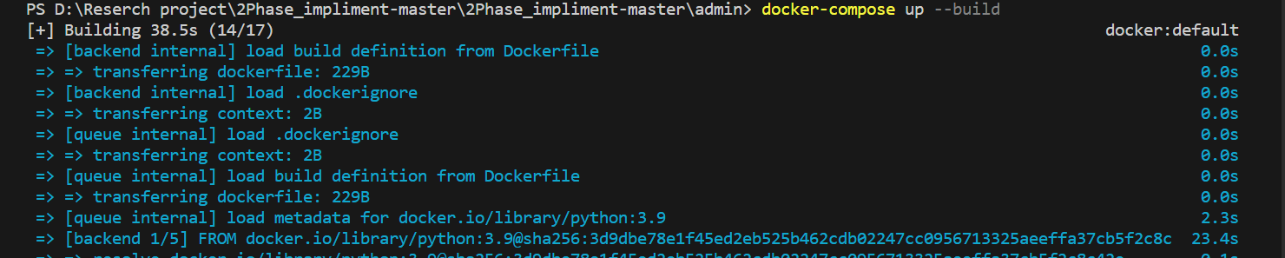

**Step 5: Verify the deployed service ‘admin’ on docker.**

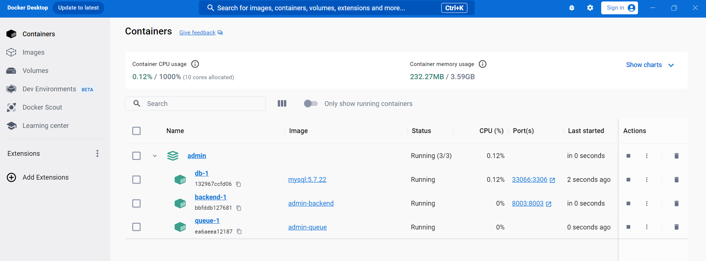

Here we can see ‘admin’ microservice is deployed successfully. And it is Up and Running.

**Step 6: Follow the same procedure to deploy the microservice 'main1' as 'admin' on Docker.**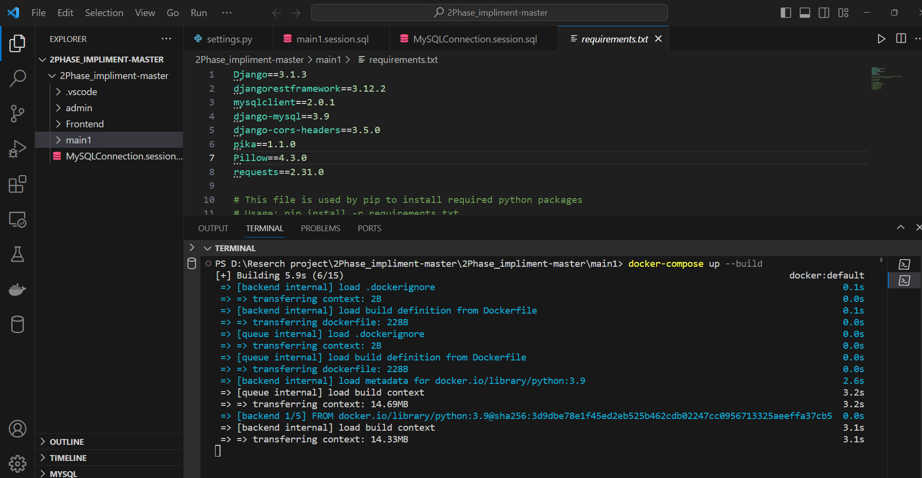

**Step 7: Verify the deployed service ‘main1’ on docker.**

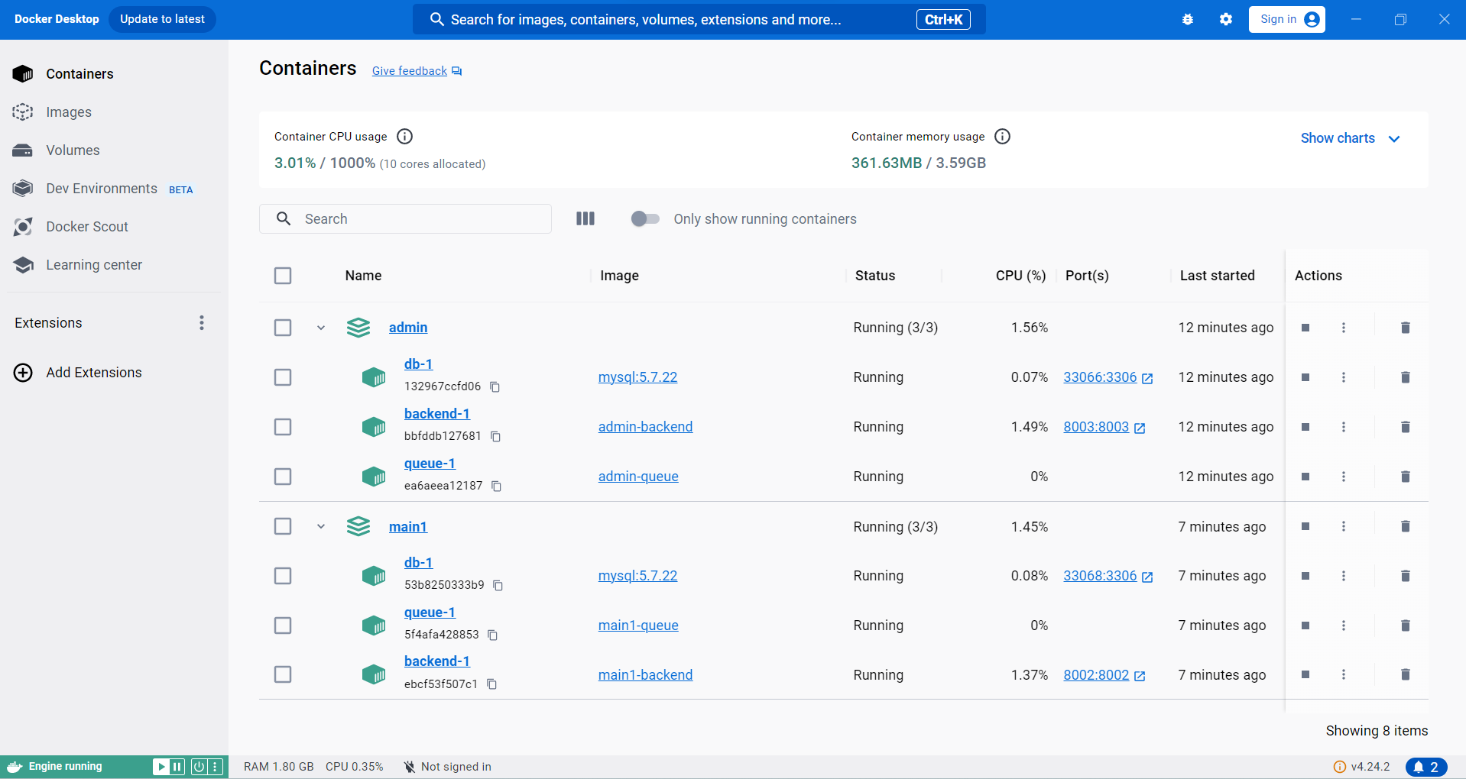

Here we can see ‘main1’ microservice is deployed successfully. And it is Up and Running.

**Step 8: Start ‘Frontend’ application.**

* Open terminal for react application ‘Frontend.’

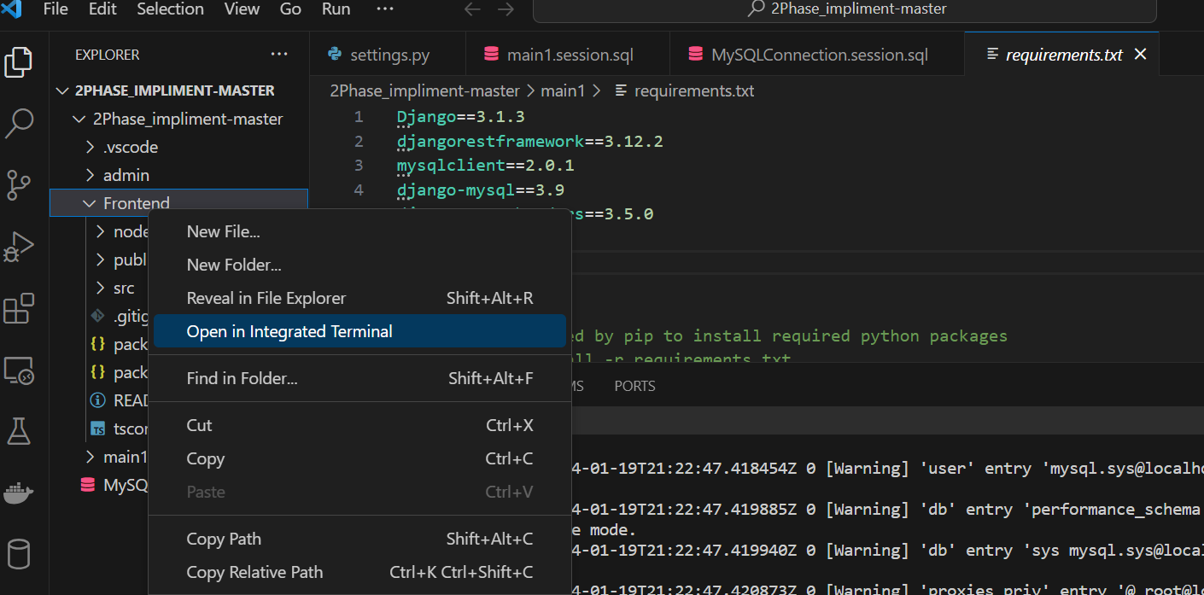

* Verify if ‘npm’ command is working at desired location or not. Otherwise install npm with command- ‘**npm install**’
* Then start npm with command – ‘npm start’. This will start the react application at port <http://localhost:3000>, http://192.168.56.1:3000

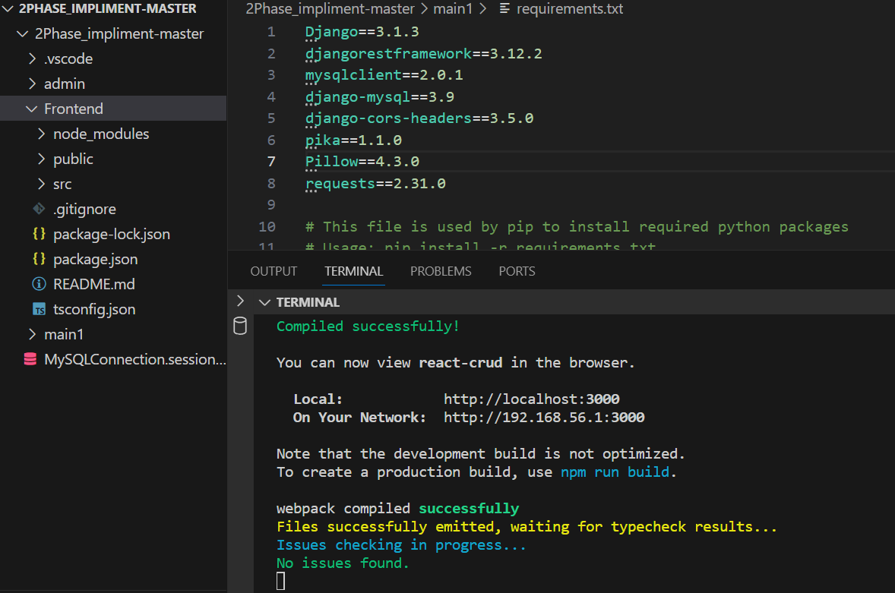

**Step 9: Open application in desired browser.**

Open Admin page with URL – ‘http://localhost:3000/admin/products’

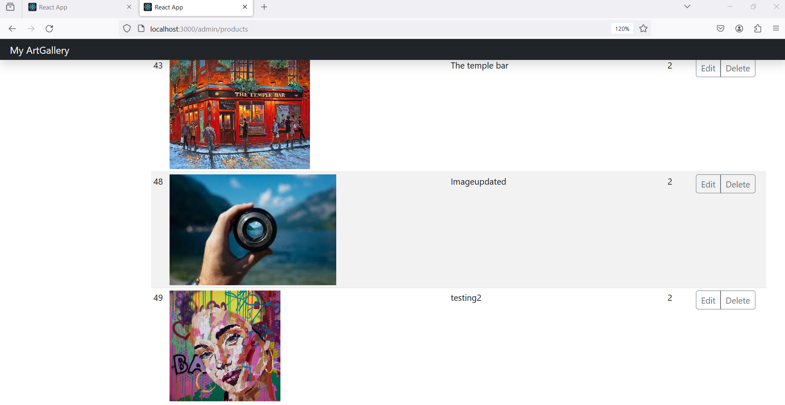

Open Main page with URL – ‘http://localhost:3000/’

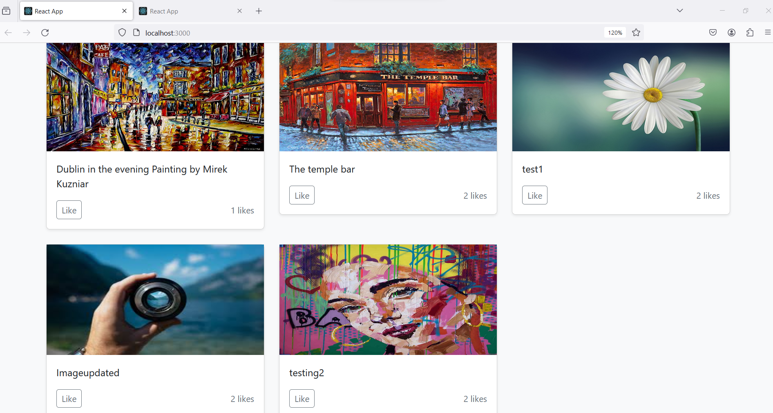

# Used case execution with result

# Normal flow without failure’’

# Use Case 1 explains the normal or expected flow when a user attempts to add, update, retrieve, or delete a product through the Admin page and tries to retrieve and like products through the Main page. Following are the steps to execute the scenarios.

# Step 1: To Update image in web application. Access the Admin page with URL - ‘http://localhost:3000/admin/products’ in the preferred browser

# Step 2: Then click on the ‘Edit’ button. This will open the Edit page. Then update the title and click on the save button.

# Step 3: This will update the image title for the selected image.

# Step 5: To check data consistency. Open Main page with URL – ‘http://localhost:3000/’ and check Same image is added on it.

# Step 6: In this manner, data consistency is maintained in the normal or regular flow. To verify data consistency for scenarios involving Add, Delete, and Like operations, one can follow the same steps and examine the results.

# Fault flow with 2PC, saga and temporary DB

# Use Case 2 Outlines the fault-handling mechanism when any of the microservices is not operational. It illustrates how the Two-Phase Commit and Saga patterns collaborate with a temporary database during the recovery process.

# Step 1: Normal flow

# Step 1: Open main page with URL – ‘http://localhost:3000/’

# 

# Step 2: Click on the like button for any product, check the incremented count. Verify incremented like count.

# 

# Step 3: Open Admin page and check like count for the same image by refreshing Admin page.

# 

# Step 4: Like count displayed for the product is matched and data consistency is achieved in normal.

# Step 2: Fault occurred: Now user tries to Like some product and fault occurs.

# Step 1: To create the fault scenario, turn of the backend service of Admin in docker

# 

# Step 3: Fault handling flow with 2PC –

# Step 1: Try to like any product on the Main page, this will not allow Main service to change the like count as Admin service is not reachable.

# Step 3: Recovery mechanism with Saga pattern –

# Step 1: To check recovery scenario turn on the backend service in docker. And wait until service comes up.

# 

# Step 2: With the implementation influenced by Saga pattern, Admin service will regain its original state and Main service will process the all the records available in temporary memory and will send it to Admin service.

# Step 4: To check the result achieved by failure recovery. Refresh the Main page check the like count for the product.

# Step 5: Open the Admin page to check the like count of the same product which will be equal.

